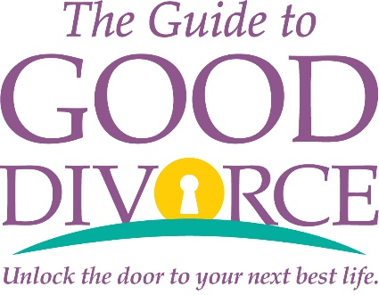

Seminar Agenda
Saturday, July 24, 2021
8:30 a.m. – 2:00 p.m.

8:30 a.m. Check-in & Light Brunch

9:00 a.m. - Introduction & Welcome
10:50 a.m. Trey Yates, Board Certified Family Law Attorney
Founder of The Guide to Good Divorce℠

The Five Keys to Good Divorce

The Law of Divorce in Texas

11:00 a.m. - The Financial Side of Divorce
12:00 p.m. Molly Ward, CFP, CDFA

12:00 p.m. - break
12:15 pm

12:15 p.m. - A Practical Guide to Moving Forward in Wellness After Divorce
12:45 p.m. Nan Hall Linke, M.A.B.S.

12:45 p.m. - Special Needs Divorce: From Overwhelm to Success
1:15 p.m. Mary Ann Hughes, former client, The Guide to Good Divorce℠

1:00 p.m. – Wellness & Tibetan Bowl Meditation
1:30 p.m. Farahana Surya Kassam, FSN

1:30 p.m. - Circle of Gratitude
1:40 p.m.

1:40 p.m. - Tiffany's necklace drawing (winner must be present to win)
1:45 p.m.

1:45 p.m. “Ask the Experts” Q&A Panel
2:00 p.m. Trey Yates, Molly Ward, Nan Hall Linke, Mary Ann Hughes

2:00 p.m. Conclusion, Networking, Evaluation Forms

